RetinXplain – An explainable AI for Diabetic Retinopathy detection and grading using a user-centric approach

Smridhi Patwari
95-891 – Introduction to Artificial Intelligence
Artificial Intelligence Systems Management Programme
9th December 2025

Table of Contents
Executive Summary 3
1. Introduction 3
1.1 Problem Definition 3
1.2 Why This Problem Matters 4
2. Background and Workflow Challenges 5
2.1 Different Stages of DR Classifier 5
2.2 Current methods of DR screening in LMICs 5
2.3 Transforming DR Screening Through AI Technologies 6
3. Dataset & Exploratory Data Analysis 7
3.1 Dataset Description 7
3.2 Data Challenges Identified 8
3.3 Implications of Dataset on Model Behaviour 8
4. Methodology 8
4.1 Model Architectures 4.1.1 ResNet-50 8
4.1.2 EfficientNet-B4 9
4.2 Handling Class Imbalance 9
4.3 Augmentation & Preprocessing 9
5. Results 10
5.1 Quantitative Results 10
5.2 Explainability Results 11
6. Lessons Learnt 12
7. User Interface and Human Centricity 13
Limitations 14
8. Future Work 14
10. Conclusion 15
Appendix: 17

Executive Summary
Diabetic Retinopathy (DR) is the leading cause of preventable blindness among working-age adults [1]. Yet over 77% of people with diabetes in low- and middle-income countries lack regular retinal screening due to shortages of ophthalmologists and diagnostic infrastructure [2].
In such regions, screening often depends on technicians or primary-care staff capturing retinal photos that are later sent to distant specialists which is a slow, error-prone process. Automated DR classifiers could bridge this gap, but current AI tools act as “black boxes.” Clinicians and technicians often distrust them because they cannot interpret why an image was flagged as “severe.”
RetinXplain addresses this gap by developing an explainable AI system that classifies DR severity and visually highlights the affected retinal regions. The focus is on human-centered trust and transparency enabling non-specialist health workers, tele-ophthalmology hubs, and clinicians in resource-limited settings to interpret AI results confidently.

1. Introduction

1.1 Problem Definition
Diabetic Retinopathy is a microvascular complication of diabetes that causes progressive damage to the retinal capillaries and the macula of the eye [3]. It affects millions globally across both developed and low- and middle-income countries (LMICs). The global burden of DR is illustrated in Figure 1, showing the highest prevalence in the Western Pacific region (East Asia, Southeast Asia, Australia, and New Zealand), followed by South Asia, North America, and North Africa.
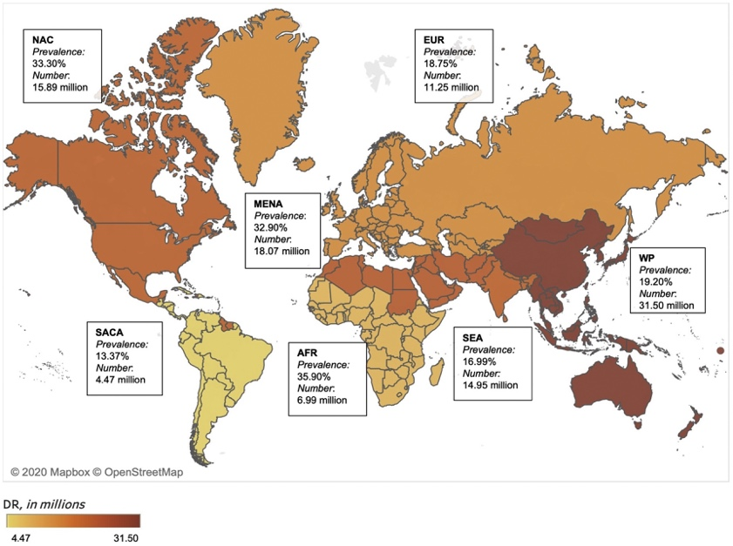
Figure 1: Global Prevalence of DR by region [4]

1.2 Why This Problem Matters
Although DR is a worldwide health concern, LMICs are disproportionately affected because they are the least equipped to manage the disease. These countries face several persistent challenges:
- Underfunding for DR screening programmes
- Limited access to ophthalmological services and trained personnel, particularly in rural or geographically isolated areas
- Insufficient infrastructure and operational capacity to conduct routine, large-scale screenings
These factors [2] significantly delay diagnosis, leading to under-detection of early-stage disease and inadequate follow-up care. As a result, patients in LMICs face an increased risk of irreversible vision loss despite early-stage DR being highly preventable and treatable.
With the rising global prevalence of diabetes and a growing number of individuals at risk of developing DR, the gap between screening needs and available healthcare resources continues to widen. Current screening systems in LMICs are unable to scale to meet demand, and traditional ophthalmologist-led workflows cannot reach all at-risk populations in time.
The situation highlights the urgent need for a more robust and scalable strategy for early detection of DR in LMICs that also factor in remote accessibility and cost effectiveness. Artificial Intelligence-based DR screening tools have emerged as a promising approach to address this gap by offering automated analysis, consistent grading performance, and the potential to extend screening services to underserved communities.

2. Background and Workflow Challenges

2.1 Different Stages of DR Classifier
Diabetic Retinopathy (DR) progresses through well-defined stages, each characterized by specific pathological changes visible on retinal fundus images. The International Clinical DR Severity Scale [5] classifies DR into 5 stages, ranging from no detectable disease to sight-threatening proliferative changes [6].
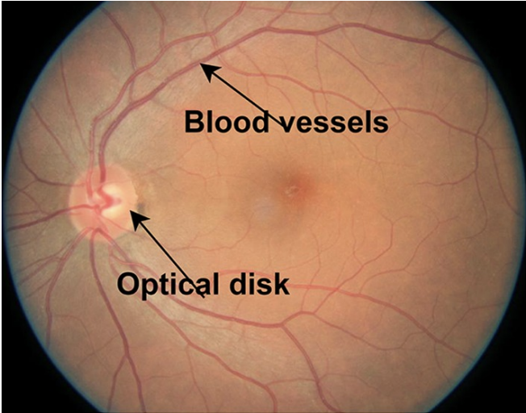
0 - Normal Eye (no DR)
Figure 2: Normal Eye Fundus Image
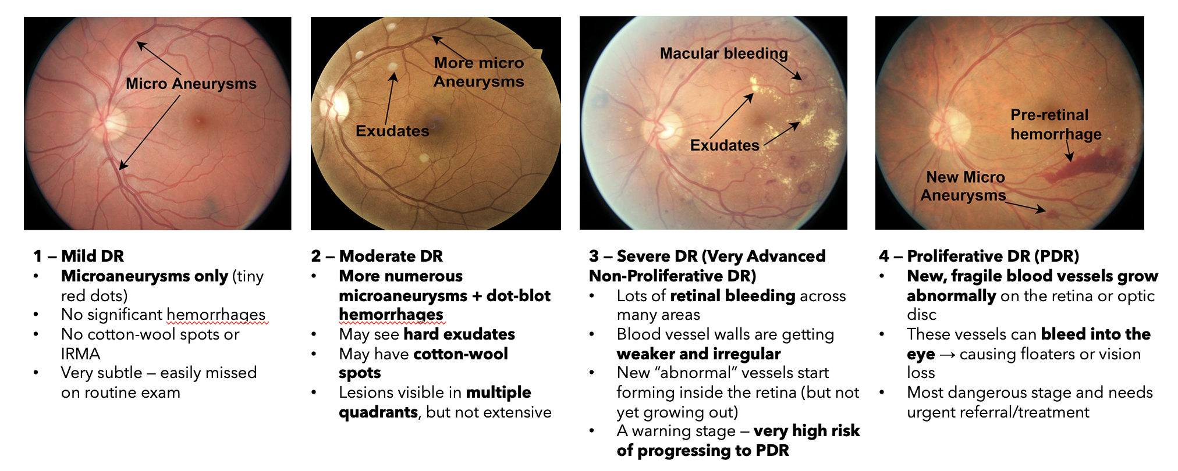
Figure 3: DR Stages of Development by the appearance of features [6]
DR is a highly preventable cause of blindness when screening is performed regularly, and early detection can prevent the disease progression to severe and beyond more than 90% of the time [7] .

2.2 Current methods of DR screening in LMICs
Screening for DR in LMICs remains challenging since due to the lack of trained ophthalmologists/optometrists. Moreover, the retinal images are captured by nurses or technicians using basic handheld cameras or smartphone adapters such Non-Mydriatic Fundus Cameras (NMFCs) or Smartphone fundus cameras like the ones in the figures below.
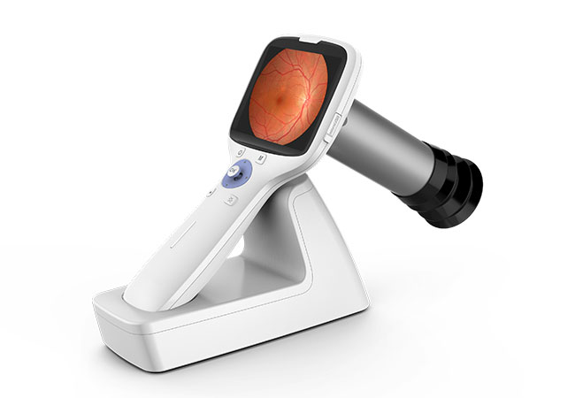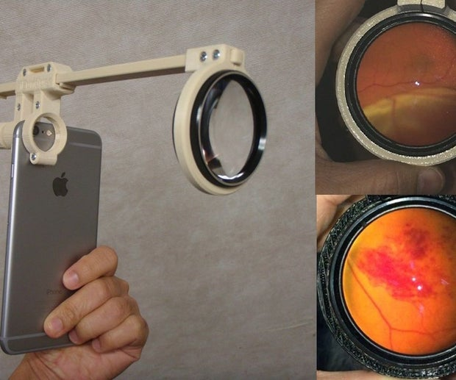
Figure 4: Non-Mydriatic Fundus Camera (NMFC )[8] Figure 5: Smartphone fundus Camera [9]

These devices often produce variable-quality images due to factors such as small pupils, poor ambient lighting, motion blur, shaky hands, and inconsistent user technique [10]. Images may be unclear, low resolution, or poorly centered, which makes it difficult to detect subtle early-stage DR features like microaneurysms and fine hemorrhages [11]. As early lesions are small and faint, even minor image degradation can significantly reduce diagnostic accuracy.
Moreover, after the images are taken, they are often stored locally or shared manually via email or messaging applications. These processes lead to long delays before a specialise can review them [12]. In rural settings, the patient might have to wait for wait extended periods or travel substantial distances for a single retinal image, and follow-up rates are often low.

2.3 Transforming DR Screening Through AI Technologies
Explainable AI-based DR screening tools have the potential to fundamentally reshape the screening workflow by delivering automated and reliable analysis of fundus images directly at the point of care. Rather than depending entirely on ophthalmologists to grade every image, the AI system can provide an immediate assessment by checking image quality, detecting key retinal lesions, and assigning a DR severity level. The use of explainability techniques such as Grad-CAM, LIME, or SHAP further strengthens this process by highlighting the areas of the image that contributed to the model’s decision. This helps frontline healthcare workers understand and verify the output, building confidence in the system.
The figures below illustrate this transformation through the RetinXplain system. The first diagram outlines the current DR screening workflow, where image capture, transfer, and grading are carried out in separate steps and depend heavily on specialist availability. This approach takes an estimated of 3-12 weeks to a complete diagnosis pathway.
The second diagram presents the RetinXplain AI-enabled workflow, which integrates automated image analysis and real-time triage at the point of care. This approach reduces the time taken for complete diagnosis significantly to just between 1-3 days depending on the clinic.
Current DR Screening Workflow:
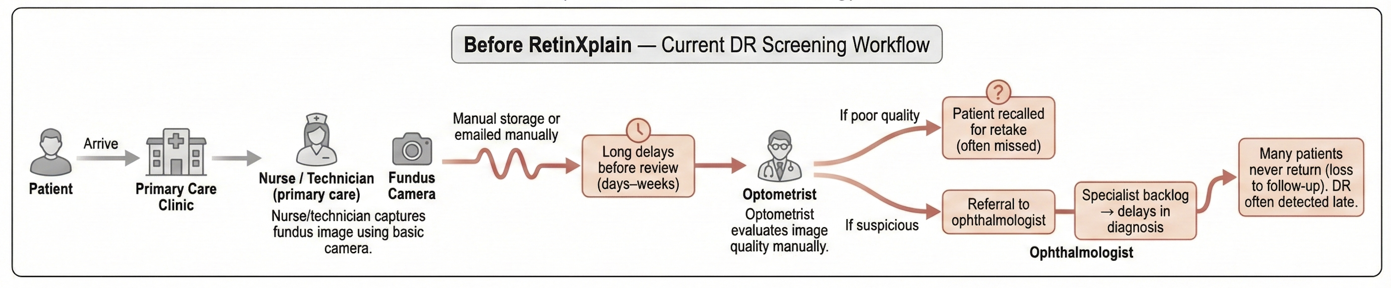
Figure 6: Current DR Screening Workflow
RetinXplain DR Screening Workflow:
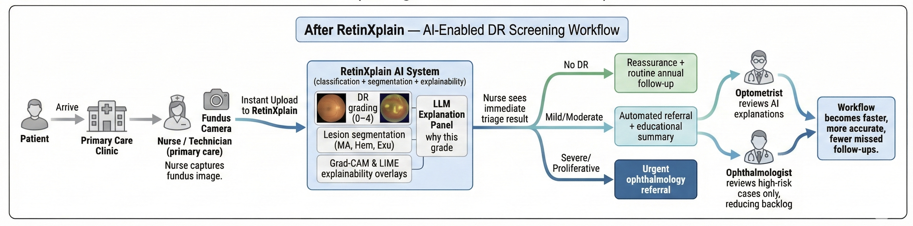
Figure 7: RetinXplain DR Screening Workflow
With the inclusion of explainable AI directly into the DR screening process, RetinXplain reduces diagnostic delays, improves grading consistency, and supports earlier identification of patients who require urgent referral, ultimately creating a more reliable and efficient pathway from image capture to clinical decision-making.

3. Dataset & Exploratory Data Analysis

3.1 Dataset Description
The APTOS 2019 Blindness Detection dataset was used to train and evaluate RetinXplain. It contains colour fundus images labelled across five levels of diabetic retinopathy severity. The images vary in resolution, lighting, clarity, and camera type, which reflects the diversity of real-world screening conditions. An 80/20 stratified split was applied so that the natural distribution of disease stages was preserved across both training and validation sets.
A brief visual review of the dataset highlighted differences in lesion visibility, image framing, and overall quality, which helped guide the preprocessing and augmentation steps used later.

3.2 Data Challenges Identified
The dataset showed a strong imbalance, with 1,434 images labeled as No DR compared to much smaller counts for Mild DR (300), Severe DR (154), and Proliferative DR (234). This made it difficult for the models to learn the features of the early and severe stages, since the majority class dominated the training process.
There was also considerable variation in image quality. Some images were blurred or dim, while others were cropped inconsistently or contained dark borders. These issues often occur in real screening environments and can hide the subtle lesions that are important for distinguishing early-stage DR.

3.3 Implications of Dataset on Model Behaviour
The dataset characteristics directly shaped how the models learned. Because of the imbalance, early versions of the model tended to predict No DR for most images, which produced high accuracy without meaningful clinical value.
ResNet50 responded more consistently to balancing strategies and showed gradual improvement across all classes. EfficientNet B4 learned much faster and became unstable when the same techniques were applied, which led to rapid overfitting and very low validation accuracy.
Explainability tools also confirmed these issues. Grad CAM and LIME showed scattered and irrelevant attention patterns until balancing and augmentation were added. Once the dataset was better handled, the attention maps became more aligned with real retinal lesions, showing that the quality and distribution of the data had a strong influence on both performance and interpretability.

4. Methodology

4.1 Model Architectures
4.1.1 ResNet-50
ResNet-50 was selected as the first model because of its strong performance in medical imaging tasks and its stable training behaviour. Its residual connections allow the network to learn deeper feature representations without losing gradient information, which is helpful when distinguishing subtle differences between DR stages. In early experiments, ResNet-50 proved more resilient to class imbalance and image variability. It responded well to strategies such as weighted sampling and focal loss, and it produced more clinically meaningful explainability maps once the training data were balanced.

4.1.2 EfficientNet-B4
EfficientNet-B4 was chosen to evaluate the effects of a more modern architecture. This model is known for strong performance across many vision tasks. However, it learns much faster than ResNet-50, which made training more sensitive to imbalance. When the same balancing techniques used for ResNet-50 were applied here, EfficientNet-B4 began to overfit very quickly. Training accuracy rose sharply while validation accuracy stayed low. This behaviour suggested that EfficientNet-B4 was memorising examples from the minority classes instead of learning general patterns. As a result, additional tuning and more conservative balancing strategies were required for this model.
4.2 Handling Class Imbalance
Class imbalance was one of the most important factors influencing model behaviour. Since the majority of the dataset consisted of No DR images, the models initially learned to favour this class. To address this, two balancing strategies were applied.
- WeightedRandomSampler increased the sampling frequency of underrepresented classes during each training epoch. This gave the model more opportunities to learn from mild, severe, and proliferative cases.
- Focal loss this loss function reduces the influence of easy examples and encourages the model to focus on harder samples.

4.3 Augmentation & Preprocessing
Data augmentation was applied to improve the model’s ability to generalise across the natural variation present in fundus images. The augmentations included random rotations, horizontal flips, colour adjustments, and random cropping. These transformations helped simulate the variability seen in images captured with different devices or under inconsistent lighting conditions.
Preprocessing steps included resizing the images to match the expected input dimensions of each model and normalising pixel values.

5. Results

5.1 Quantitative Results
- Confusion Matrix
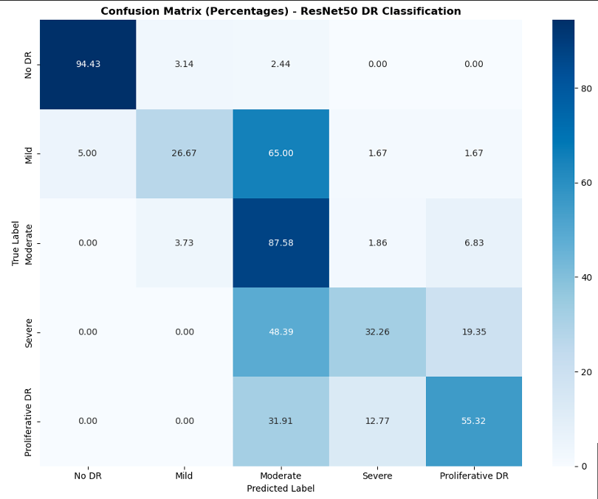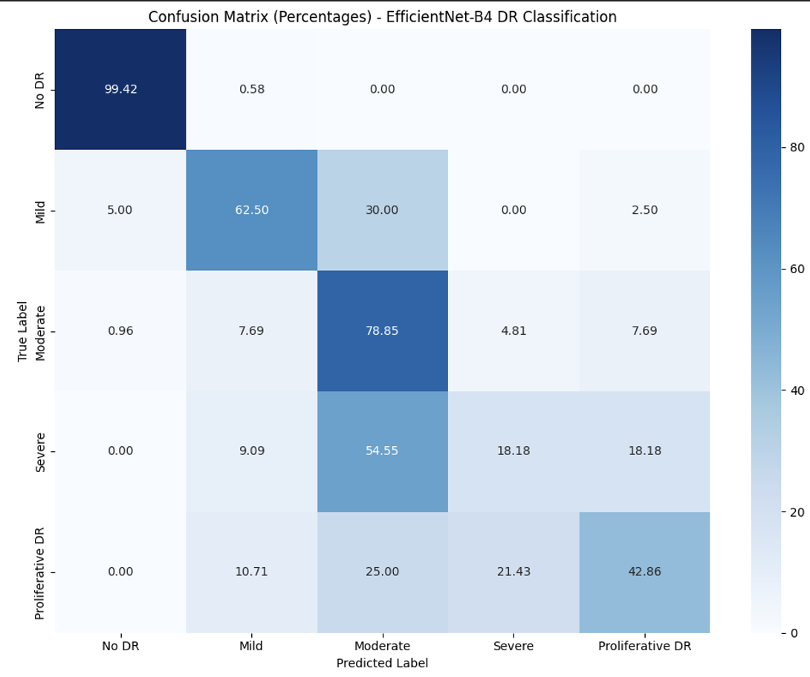
Figure 8: ResNet-50 Confusion Matrix Figure 9: EfficientNet-B4 Confusion Matrix
Both confusion matrices show that the five-class DR task is challenging because the boundaries between stages are subtle and often overlap. Both models perform best on No DR, which is expected, but this also carries a risk since false negatives here could delay needed follow-up. Mild DR remains the hardest class for both models because the early lesions are small and easy to miss, but EfficientNet shows noticeably better recall than ResNet for this stage.
For Moderate DR, both models perform well, with ResNet slightly more stable. Severe DR shows the largest confusion for both networks, often being predicted as Moderate or Proliferative. This is important clinically because misclassifying Severe as a less urgent class could lead to inaction. Proliferative DR is reasonably well detected by both models, though each struggles with the small number of available samples.
- Metric Comparison table
Metric | ResNet-50 | EfficientNet-B4 | Which Model Performs Better?
Accuracy | 0.792 | 0.803 | EfficientNet-B4
F1 | 0.781 | 0.796 | EfficientNet-B4
Recall | 0.792 | 0.803 | EfficientNet-B4
AUC | 0.898 | 0.921 | EfficientNet-B4
Figure 10: ResNet50 - vs EfficientNetB4 model comparison
Overall the EfficientNet-B4 model outperformed the ResNet-50 on 4 key metrices. Generally, the Recall score is one of the most important metrics for ths project since it shows how many actual disease cases the model is able to catch. A higher recall means the system is safer and fewer patients with disease will be incorrectly reassured.
Both models also have high AUC values which indicate that the model separates each DR clas well across decision thresholds. The higher AUC values show that the model can reliably distinguish between healthy and diseased eyes and across different severity levels.
However, from the table, it can also be seen that the Accuracy and the Recall are both the same for both theResNet50 and the EfficientNetB4. This indicates a high class imbalance in the dataset where most of the correct predictions come from the largest classs (in this case no DR).

5.2 Explainability Results
To understand how each model arrived at its predictions, Grad-CAM++ and LIME were applied to sample images across different DR stages. Both methods helped reveal whether the models were focusing on clinically meaningful regions. The figures below show the comparison between the grad Cam heatmaps and lime predictions generated from the 2 different models.
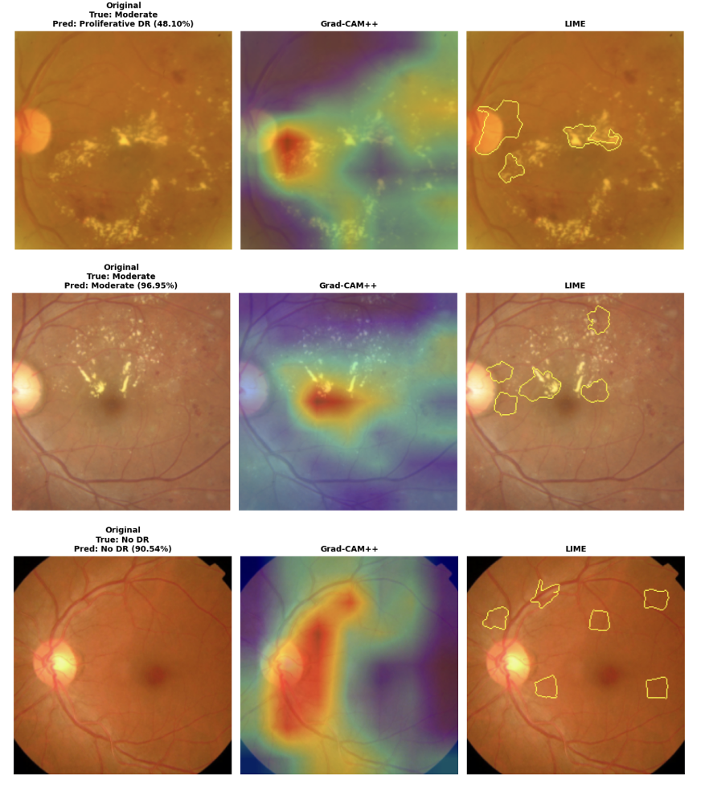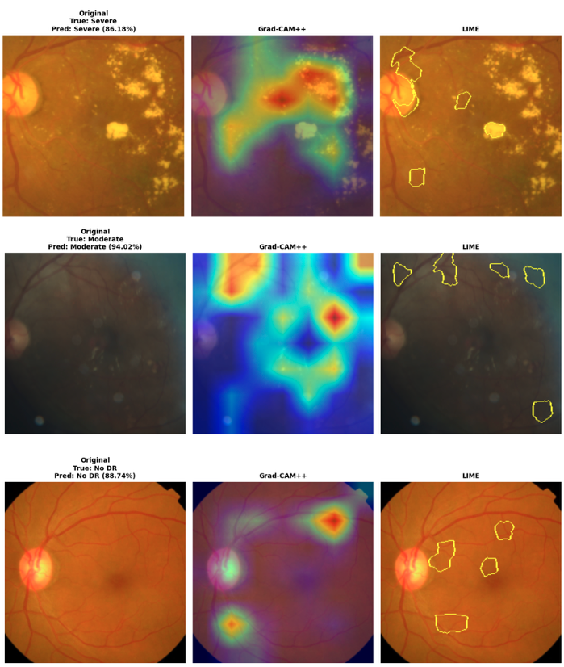
Figure 11: ResNet - 50 explainability result Figure 12: EfficientNetB4 explainability Result
For both ResNet-50 and EfficientNet-B4, the Grad-CAM++ heatmaps consistently highlighted clinically meaningful regions, giving a clear sense of what the model relied on when making its predictions. The attention became more focused and pronounced as the severity increased, which aligns with how lesion visibility changes across DR stages. Grad-CAM++ therefore provided an intuitive and reliable way to interpret the model's decisions.
However, displaying heatmaps for healthy eyes can be misleading, because the highlighted regions reflect where the model is paying attention rather than actual pathology. Heatmaps do not indicate disease in No DR images; they simply show the features the model considered before deciding the eye is healthy.
LIME offered more local, patch-based explanations by isolating small areas that influenced the prediction. While this helped reveal fine-grained lesion patterns, it was also much more sensitive to noise. In lower-quality images, LIME occasionally highlighted irrelevant regions, which made the explanations less stable.
Given the intended use case in screening settings such as integrated diabetes clinics, it may not be necessary to include both methods. Grad-CAM++ already provides a clear, actionable explanation that supports clinical decision-making, and it is lighter and faster to generate. LIME, although informative, is computationally heavier and more prone to noise, which makes it less practical for environments where resources and latency matter. Keeping the explainability pipeline simple and efficient is more suitable for real-world deployment.

6. Lessons Learnt
- Class imbalance makes a big difference in the results
It is crucial to perform EDA early and understand the distribution of classes before training any model. Not handling imbalances can result in the model overtraining on the majority classes and, leading to misleading accuracy and unreliable performance. In medical imaging, the stakes are generally higher. For the use case of DR screening in LIDCs, the false negatives and missed detection can result in an individual not being able to get timely care, leading to preventable deterioration of the quality of life of the individual.

- Balancing the dataset changed both where the model looked and how it predicted.
After introducing class weighting / sampling strategies, the model’s attention maps aligned more closely with real DR lesions (microaneurysms, hemorrhages, exudates), demonstrating better clinical grounding.

- Explainability exposed what accuracy alone could not
Grad-CAM consistently showed that before handling imbalance, the model was looking at irrelevant areas despite having high accuracy. This made it clear that accuracy on its own can be misleading, especially in medical AI where understanding why a model made a prediction is just as important as the prediction itself. Explainability helped uncover these hidden failure modes early, allowing the training process to be corrected before deployment.
- Understanding use case before designing solutions ( user-centric solutions)
It is often tempting to look for a problem that justifies using a new technology, rather than starting with a real need and choosing the method that fits it. In this project, LIME was a helpful tool for comparing explanations with Grad-CAM++, but it does not make practical sense to include both in the final platform. Adding two different visual explanations would make the system less intuitive, especially for frontline staff who may not have technical training. Grad-CAM++ already provides clear, clinically meaningful insights, and keeping the explanation layer simple ultimately supports better usability in screening environments.

7. User Interface and Human Centricity
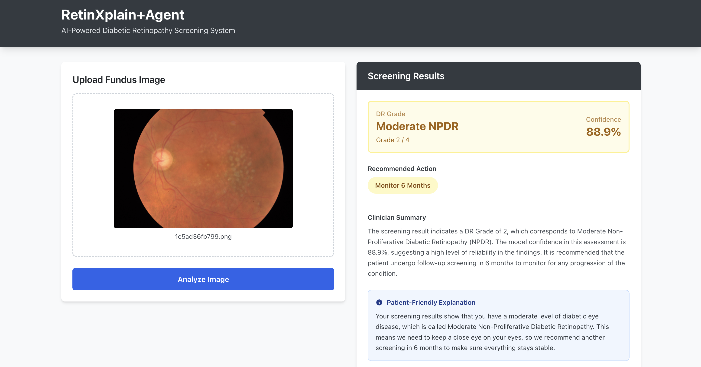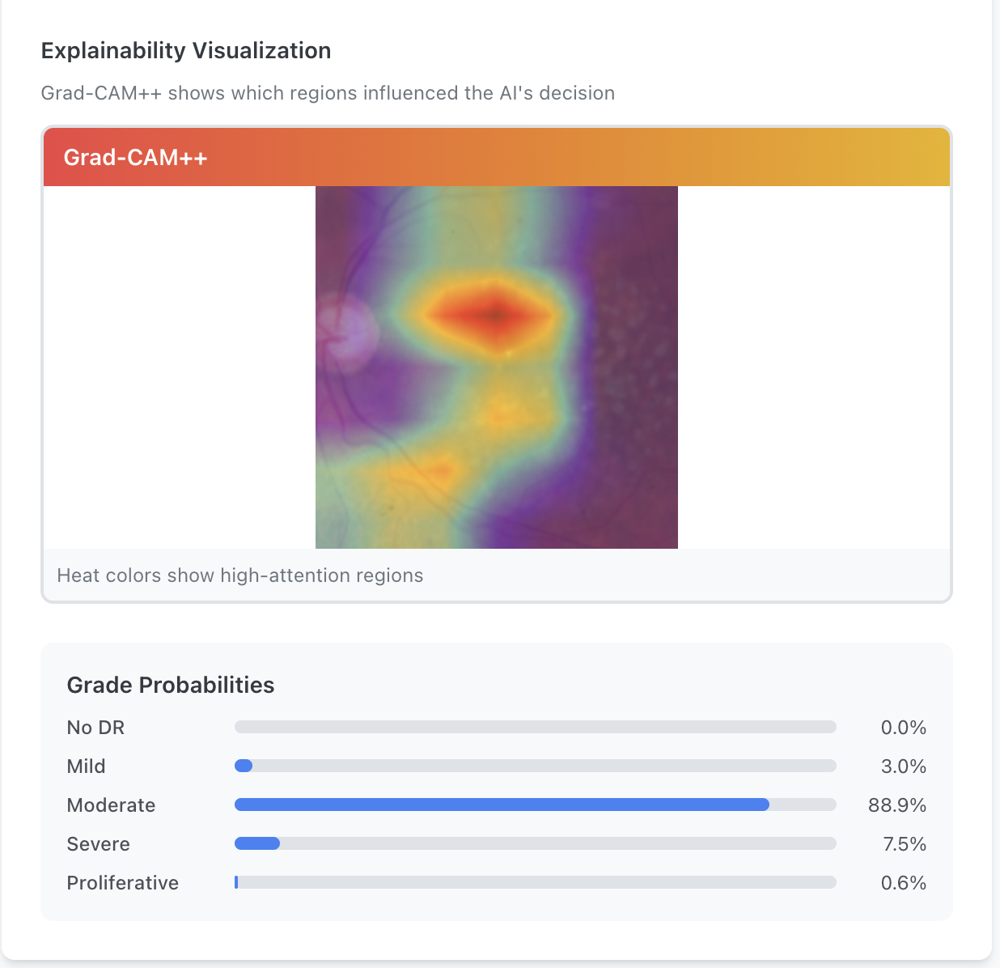
Figure 13: RetinXplain Platform
The RetinXplain platform was designed to keep the screening process clear and easy to use, particularly in busy clinics in low and middle income settings. The interface presents the predicted DR grade, the confidence score, and a short explanation for clinicians, along with a simple and reassuring summary for patients. To generate these summaries, the system uses GPT 4o mini. This model was chosen because it is lightweight, fast, and reliable, which makes it suitable for real time use in environments where compute and connectivity may be limited.
Moreover, Grad CAM heatmaps show where the model focused when making its decision, which helps clinicians quickly sense whether the reasoning aligns with visible retinal features. Overall, the user interface aims to balance clarity, safety, and human understanding, so that the system can realistically support DR screening workflows in resource constrained LMIC clinics.

Limitations
- The RetinXplain system currently uses LLM based explanations, which requires stable and fast internet for operation, It may not be feasible in middle income or remote settings where the infrastructures is often not able to support this.
- The current models (resnet50 and efficientnetb4) are also pretty heavy and may not run efficiently on low power devices. For a successfully implemented AI solution in LMICs a much lighter model will be required.
- The system is not yet validated in real clinical environments. Factors such as technician skill, camera quality, lighting, and workflow integration may affect performance, and these would need to be assessed before any real world use.

8. Future Work
There are several directions that could improve the system and bring it closer to real world deployment.
- Further Fine Tuning and Model Comparison
Continue fine tuning and comparing models such as ResNet 50, EfficientNet B0, and EfficientNet B4 in order to find the best balance between performance and efficiency.

- Selecting a Lightweight Model for Deployment
Since RetinXplain is designed for low resource and low connectivity settings, selecting or distilling a lightweight model that can run fully on device will be important for scaling the platform to remote clinics.

- Extending to a Multi Disease Classifier
any screening programs evaluate patients for several eye conditions at once, so moving from a single disease DR model to a multi label classifier capable of identifying DR, Glaucoma, Cataract, and Age related Macular Degeneration would make the platform more clinically useful.

- Improving Robustness Through Realistic Augmentation
Adding more field realistic augmentations such as motion blur, uneven illumination, and compression artifacts would help the model generalise better to images captured on low cost fundus cameras in real world settings.

- Integrating Automated Image Quality Assessment
Incorporating an image quality assessment module into the interface would allow the system to flag ungradable images and prompt retakes before running DR prediction. This would reduce false results and improve the safety and reliability of the screening workflow.

10. Conclusion
This project shows that improving diabetic retinopathy screening in low resource settings requires more than developing a high performing model. It also needs careful attention to class imbalance, image quality, explainability, and the realities of clinical workflows. ResNet-50 and EfficientNet-B4 both delivered strong results, but their behaviour under imbalance and variable image conditions confirmed that accuracy alone cannot guide model selection in medical contexts. The explainability tools were especially important because they revealed where the models were focusing and whether this aligned with real retinal lesions. These insights shaped the design of the RetinXplain platform, which aims to support frontline workers by providing clear predictions, visual heatmaps, and simple summaries for patients. Although further refinement is needed, such as selecting a lighter model, improving real world robustness, and expanding to multi disease detection, the project demonstrates that explainable AI can offer practical support for early DR identification in resource constrained settings and can contribute to safer and more accessible screening pathways.

Bibliography
[1] J. Zhang, M. Wang, L. Chen, and N. Radke, “Diabetic Blindness Remains a Big Challenge Despite All Recent Advancements in Diagnostics and Treatments,” Asia-Pac. J. Ophthalmol., vol. 13, no. 5, p. 100105, Sept. 2024, doi: 10.1016/j.apjo.2024.100105.
[2] Y. D. Lestari et al., “Diabetic retinopathy screening model in low and middle-income countries: a scoping review,” BMC Public Health, vol. 25, no. 1, p. 4210, Dec. 2025, doi: 10.1186/s12889-025-25543-6.
[3] S. UV and Tripathy K, “Diabetic Retinopathy.,” in StatPearls [Internet], Treasure Island (FL): StatPearls Publishing. [Online]. Available: https://www.ncbi.nlm.nih.gov/books/NBK560805/
[4] Z. L. Teo et al., “Global Prevalence of Diabetic Retinopathy and Projection of Burden through 2045,” Ophthalmology, vol. 128, no. 11, pp. 1580–1591, Nov. 2021, doi: 10.1016/j.ophtha.2021.04.027.
[5] C. P. Wilkinson et al., “Proposed international clinical diabetic retinopathy and diabetic macular edema disease severity scales,” Ophthalmology, vol. 110, no. 9, pp. 1677–1682, Sept. 2003, doi: 10.1016/S0161-6420(03)00475-5.
[6] A. Shamsan, E. M. Senan, and H. S. Ahmad Shatnawi, “Predicting of diabetic retinopathy development stages of fundus images using deep learning based on combined features,” PLOS ONE, vol. 18, no. 10, p. e0289555, Oct. 2023, doi: 10.1371/journal.pone.0289555.
[7] D. Tubert, “Diabetic Eye Disease,” Am. Acad. Ofd Ophthalmol., Sept. 2024, [Online]. Available: https://www.aao.org/eye-health/diseases/diabetic-eye-disease
[8] Non Mydriatic Fundus Camera Manufacturer. [Online]. Available: https://www.hongdeecorp.com/portable-fundus-camera/
[9] ophthalmicdocs in Workshop, “Smartphone Ophthalmoscope ODocs Fundus.” [Online]. Available: https://www.instructables.com/Retinal-Imaging-Device-OphthalmicDocs-Fundus/
[10] M. P. Piyasena, S. N. Hewage, and K. Banduthilake, “Retinal image quality assessment in diabetic-retinopathy screening: Real world evidence from a lower-middle income country,” Lat. Am. J. Ophthalmol., vol. 7, p. 8, June 2024, doi: 10.25259/LAJO_24_2023.
[11] H. Li et al., “Fundus Image Quality Assessment and Enhancement: a Systematic Review,” 2025, arXiv. doi: 10.48550/ARXIV.2501.11520.
[12] D. Yim, S. Chandra, R. Sondh, S. Thottarath, and S. Sivaprasad, “Barriers in establishing systematic diabetic retinopathy screening through telemedicine in low- and middle-income countries,” Indian J. Ophthalmol., vol. 69, no. 11, pp. 2987–2992, Nov. 2021, doi: 10.4103/ijo.IJO_1411_21.

Appendix:
ROC Curves
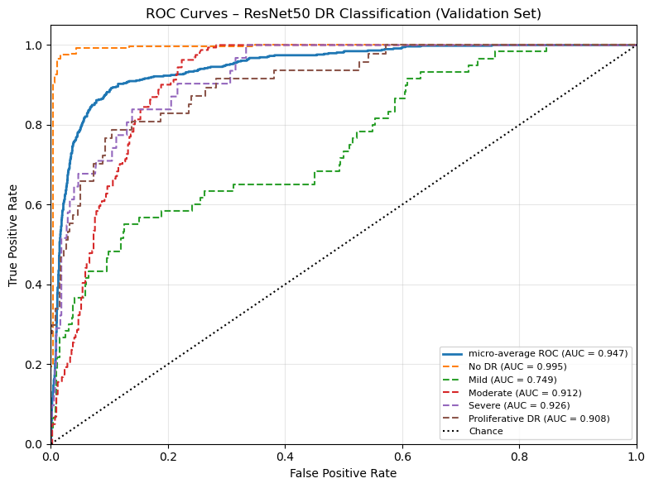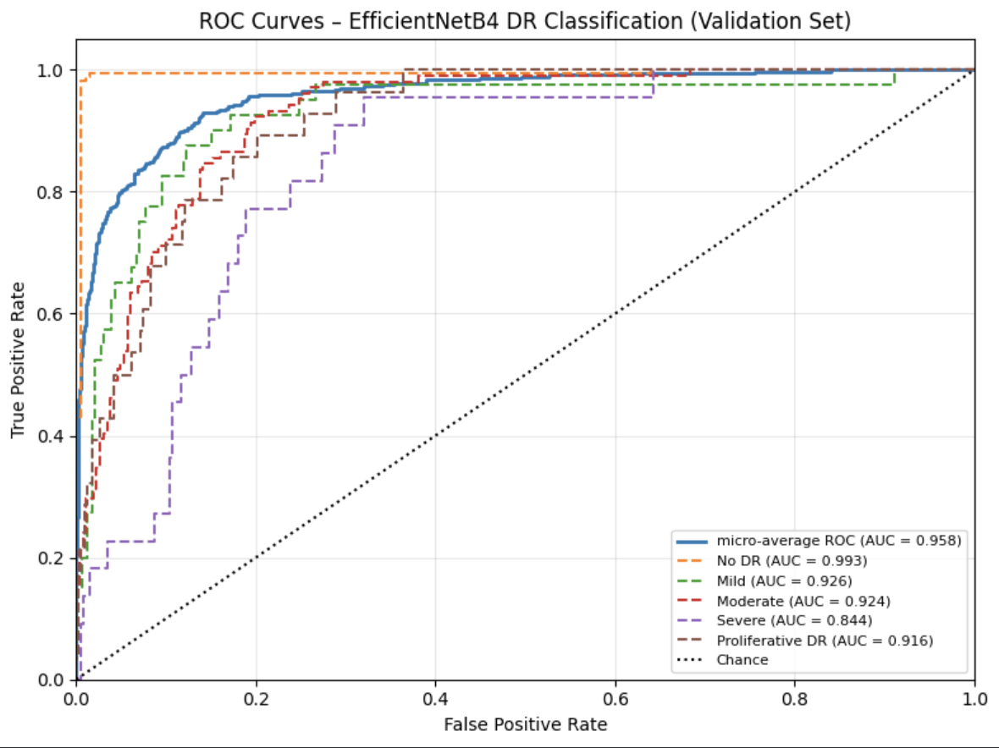
Accuracy comparisons across models
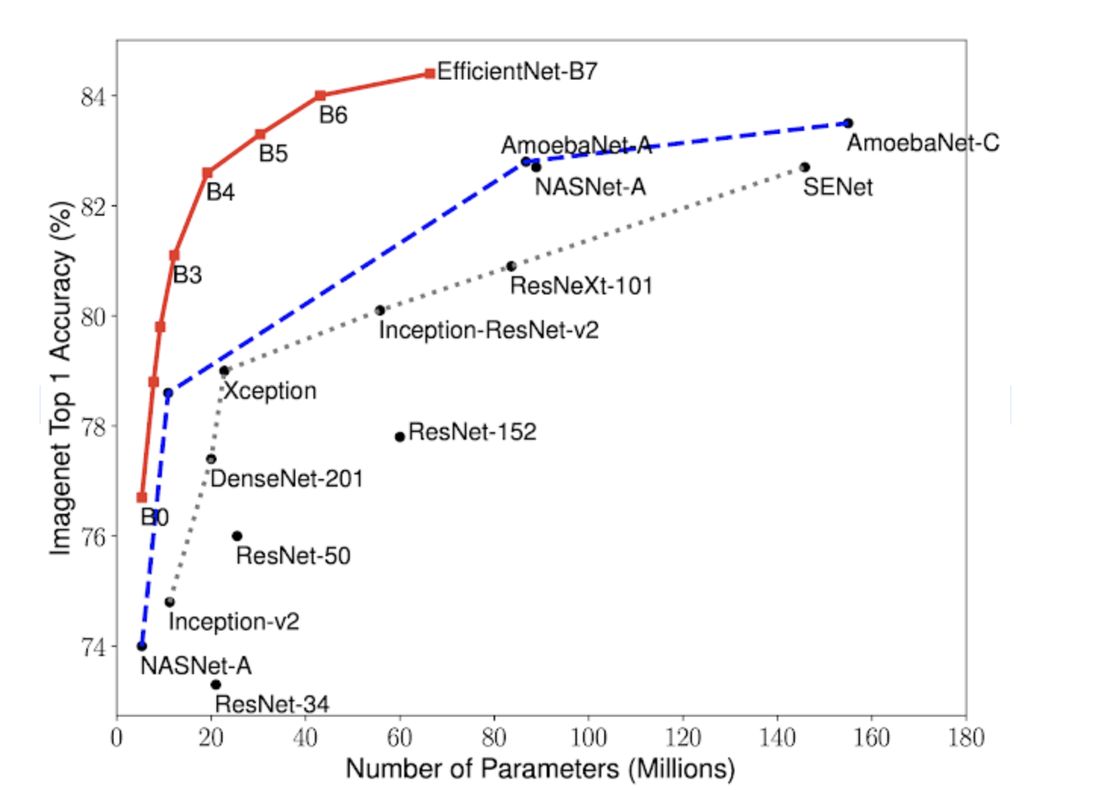
https://research.google/blog/efficientnet-improving-accuracy-and-efficiency-through-automl-and-model-scaling/

Project Github Link: https://github.com/Rriddhi/RetinXplain

